Port Erroll School and Nursery



BEHAVIOUR POLICY

Date: January 2021

Review Date: January 2023

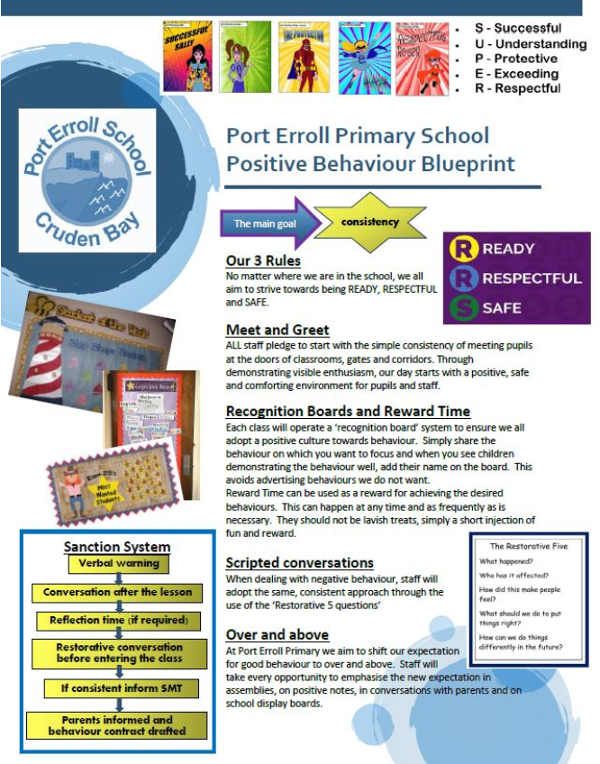

The Head Teacher at Port Erroll School welcomes feedback on this document.

Contact:

Mrs Yvonne O’Neil

Port Erroll School
Braehead Drive
Cruden Bay
Petehead
AB42 0NP

Tel. No.: 01779 403690
Email: porterroll.sch@aberdeenshire.gov.uk

