Port Erroll School

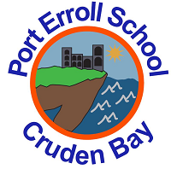

Curriculum Rationale

2020/2021

*What do we want for our children at Port Erroll Primary School?*

**Our Vision**



Port Erroll School is part of a protective, respectful community that aspires to use understanding to support one another to achieve. We strive to work as a community to challenge our learners to exceed expectations and therefore become truly successful, developing life skills preparing them for their journey ahead.

**Our Values**

In Port Erroll School, we try our best to be SUPER.​

* S - Successful​
* U - Understanding​
* P - Protective​
* E - Exceeding​
* R - Respectful

*How can we achieve this?*

**Our Aims**

* Successful – we want everyone to achieve in our school and the wider community​
* Understanding – we want everyone to be aware of their own needs and the needs of all within our community and being tolerant of the differences we have​
* Protective – we want everyone to be looked after and cared for by all​
* Exceeding – we want everyone in our community to be challenged and try their best to achieve their full potential​
* Respectful – we want everyone to show and earn the respect and to feel valued by all across our community

It is important that everyone within the school community is clear about what we are aiming to achieve through our curriculum rationale, taking into account all the factors that make our school unique. All staff are working to ensure that our unique factors, including agriculture, fishing and `places/events’ of historical interest are central to our learning and teaching, to ensure that we can achieve relevance for learning. Our starting point is our shared vision for the school and the values we identified as being important to all of us.

We aim to ensure that core skills in Literacy, Numeracy and Mathematics and Health and Wellbeing are integral across our curriculum and children are actively engaged in their own learning and identification of next steps in learning. We strive to develop enthusiasm for learning in all our children and equip them with the necessary skills for life-long learning, life and work. Our curriculum is progressive, ensuring children develop all of the knowledge, understanding and skills they require for their journey ahead.

To ensure we achieve progression and consistency as a team we follow our Learning and Teaching in Port Erroll overview. The children follow the child friendly version.

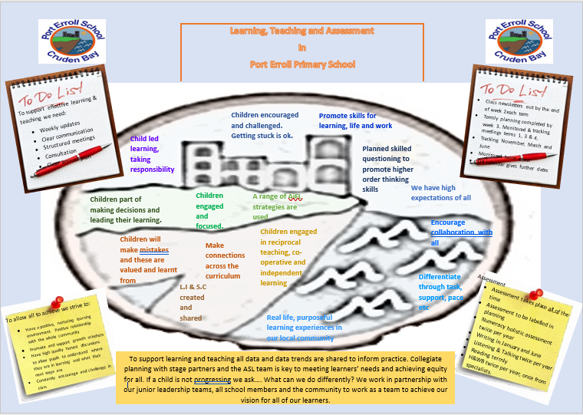

To build onto this we have also created a visual to represent our Curriculum Rationale with more detail following this.

**Curriculum Rationale**

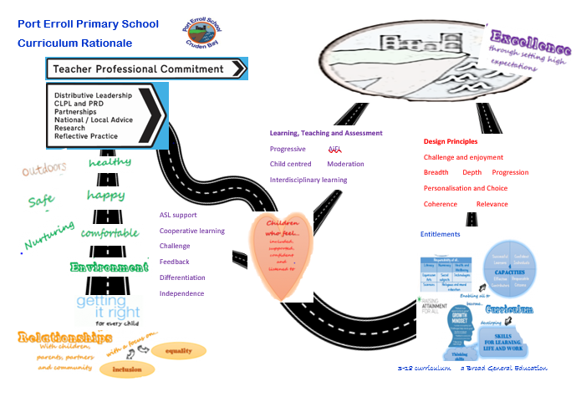

Our curriculum is planned through the four contexts

|  |  |
| --- | --- |
| Curriculum and Subject Areas   * Active Literacy Programme * Modern Languages * Maths and Numeracy * Religious and Moral Education * STEM – science, technology, engineering and maths * Social Studies * Expressive Arts * Health and Wellbeing * Whole School Events and Topics | Interdisciplinary Learning (IDL)   * Whole school events and topics * Outdoor learning * Exciting Contexts * Enrichment Opportunities * Bundling of Expectations and Outcomes to ensure breadth, depth and progression * Big Questions * Transferrable Skills * Working with the community |
| Ethos / life of the school   * Welcoming, Inclusive, community spirited * Clear expectations of behaviour * Support for inclusion * Regular visitors to the school * Hard working staff / pupils * Sustainability * Open Afternoons * Celebration Assemblies * Regular School Updates * After-School Clubs * Sports Day * Community Involvement - Coffee Mornings * Active Schools Events | Personal Achievement   * Successes celebrated –Star Wall, Celebration Assemblies, Reward System, House Points * Learning Logs and Target Setting * Planned opportunities for personal achievement – First Aid Training, Bikeability, musical instruction, House Captains, Christmas Performance and wider achievement display wall |

7 design principles – intrinsic to all we plan / teach

**Breadth**

∙ Opportunities to apply learning across the curriculum

∙ Experiences and Outcomes bundled

∙ Continuous Assessment

∙ Holistic Approach

**Challenge and Enjoyment**

∙ Engaging Activities

∙ Use of KWL at beginning of cross curricular topics (what we know, what we want to know and what we learned)

∙ Activities are motivating and active

∙ We have high expectations for all

**Depth**

∙ Play based learning is a focus in Early Years

∙ Higher Order Thinking Skills are encouraged

∙ Opportunities for pupil to transfer skills

∙ IDL will be developed throughout school

**Progression**

∙ Use of Literacy and Numeracy progressions to ensure all learners follow appropriate pathways

∙ Use of National Frameworks and Benchmarks provide reference to ensure progression

∙ Target setting

**Relevance**

∙ Real life experiences are supported

∙ Outdoor learning is encouraged

∙ Use of real life contexts

∙ Flexible cross curricular themes

∙ IEPs for children who require targeted support

**Personalisation and Choice**

∙ Pupils set targets which are shared with parents through Learning Logs

∙ Pupils involved in the planning process for cross curricular themes

∙ Big Book Planning (ELC)

∙ Responsive Planning

**Our Curriculum will**:

∙ Encourage learners to contribute to the ethos and life of the school community

∙ Provide a broad general education

∙ Recognise and deliver curriculum for excellence experiences and outcomes

∙ Support active learning

∙ Support progression for all

**Coherence**

∙ Robust Transitions

∙ Continual progression professional dialogue

∙ Robust moderation and tracking of achievement

∙ Promote the learning of skills for learning, life and work

|  |  |
| --- | --- |
| **Successful Learners**   * Reflective, enthusiastic and motivated * Opportunities to work co-operatively / independently * Developing skills across the curriculum | **Effective Contributors**   * House Captains (elected members) * Pupil Council (elected members) * Leadership Team (elected members) * School Groups – Eco, Digital Leaders, HWB, Citizenship, Charities. * Fundraising / Enterprising Activities * Buddies * Coffee Mornings |
| **Confident Individuals**   * Opportunities to Perform / be creative * First Aid Training p5 – 7 * Leavers’ Assembly * Performance group * Christmas Performances * Cluster Sports Competitions * Active School Events | **Responsible Citizens**   * House System in place * Celebrations / Events * Sustainability / care for their community and beyond * Celebration Assemblies * Cookery Skills * Coastal safety * Water safety |

Our pupils at Port Erroll are nurtured and encouraged to develop as:

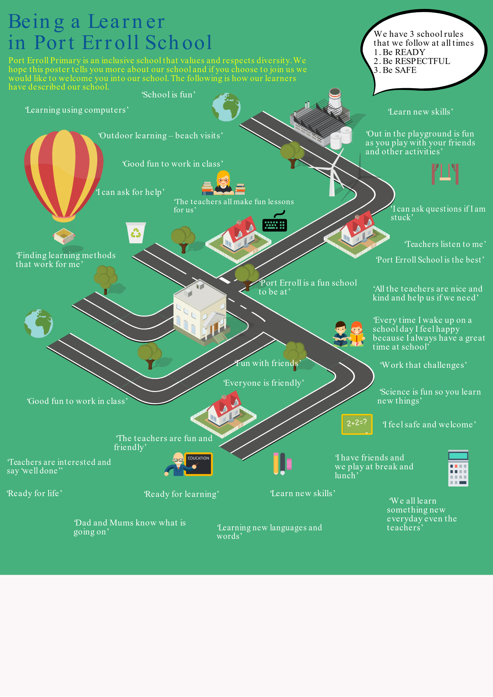June 2019

* reviewed March 2020. Review date August 2021