Port Erroll Primary School
Handwriting Policy
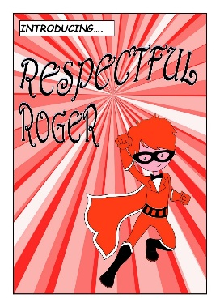
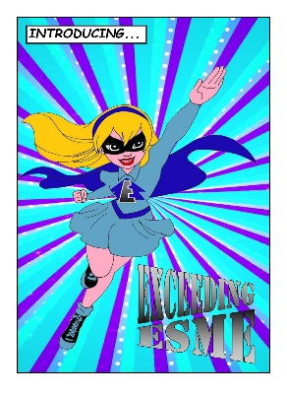
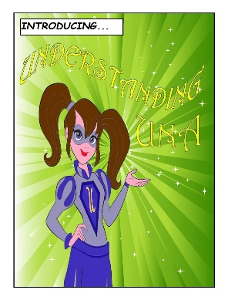
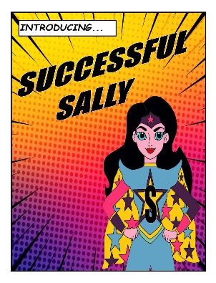
Date | January 2021
Review Date | January 2024

Overview
The purpose of this policy is to ensure a consistent approach for handwriting across the whole school which all children and staff recognise, understand and follow.

“All practitioners-from early years, through primary and secondary education, in youth work settings and in colleges are in a position to make important contributions to developing and reinforcing young people’s literacy skills”
A Curriculum for Excellence
Literacy across Learning/Principles and Practice Paper/Building the Curriculum 1

Rationale
The ability to write fluently and legibly gives children a means to communicate their thoughts and ideas efficiently. Handwriting is a skill which must be learnt in order to provide a style which becomes simple to produce and easy to read.
Cursive handwriting helps children to learn and remember spelling patterns. It is an integral part of the multisensory technique enabling pupils to make the automatic symbol-sound relationship for spelling. We believe this raises standards in handwriting throughout the whole school, developing confidence, accuracy and fluency and improved presentation.

These expectations are intended to apply to the vast majority of children in our school. Occasionally a decision will need to be made to personalise the presentation expectations for a child who has specific needs that these expectations could be a barrier to their progress.

Aims
We aim to help all pupils enjoy learning and developing their handwriting with a sense of achievement and pride. We aim for our pupils to develop a neat, legible, speedy handwriting style using continuous cursive letters that leads to producing letters and words automatically in independent writing by:
- providing equal opportunities for all pupils to achieve success in handwriting.
- producing clear, concise, legible handwriting in all areas of the curriculum.
- developing accuracy and fluency.
- helping children recognise that handwriting is a form of communication and as such should be considered important in order for it to be effective.
- promoting confidence and self-esteem.
- encouraging children to take pride in their work.
- helping children recognise that handwriting as a life-long skill and will be a fundamental element of all forms of written communication throughout their lives.
- adopting a common approach towards handwriting by all adults when writing in children’s books, on the whiteboard or on displays/resources.
- having a consistent whole school approach to the teaching of handwriting.
Organisation of Teaching and Learning
Handwriting is an important technical skill, which is developed through specifically taught lessons using active learning approaches. During handwriting lessons the children will be expected to demonstrate this skill and will then be expected to transfer this into different curricular areas.

HANDWRITING GUIDELINES

PRIMARY 1
Young children learn by imitation and the majority of new entrants to school will have been copying writing from as young as three years old. However, only a proportion of these children will be forming their letters correctly, and indeed may be writing in capital letters having learnt to do so from environmental print. Therefore, it is vital that the correct formation is taught as quickly as possible to promote good habits and in an effort to eliminate bad ones.

Time may then be taken to reinforce them on a daily basis during P1. Children should be encouraged to write their name correctly at all times.

It should be noted that during the initial introduction of the letters, it is not necessary for the children to know the names of the sounds being shown, although the teacher will talk about their sounds as the correct formation is being taught.

These lessons should be teacher led, with the teacher demonstrating the formation and then circulating to ensure this is being done correctly.

It is recommended that teachers use a variety of materials to introduce and practise the letters – a white board is ideal for this. Pupils could also write in the air and use crayons, sand and paint.

Peer/self-evaluation
A simple way to do this is to ask the pupils to circle their best example of a letter/word and to tell a partner why they chose it. A peer may be asked to highlight or put a star next to the one they think is best and explain why.

Examples of good handwriting should be celebrated and displayed to motivate other members of the class.

Developing good hand control
Throughout P1, pupils should be given plenty of opportunities to develop hand control – plasticine, cutting out, small construction toys, jigsaws, peg boards, drawing patterns etc. These should be given/offered several times a week – they fit nicely with an active learning and literacy through play environment.

Pupils who indicate that they find handwriting difficulty would benefit from these types of activities on a daily basis.

PRIMARY 2
The children of primary two may spend the first term practising the formation of lower case letters as part of words e.g. common words and/or CVC, CCVC, CVCC words. Again, this is more effective done as a teacher led session.

Their own forename and surname is practiced, followed by the introduction and consolidation of capital letters.

To develop good handwriting in all areas of the curriculum, ordinary lined jotters should be used rather than specialised handwriting jotters.

At this stage, handwriting should still be taught as a whole class, 2-3 times a week within active literacy lessons or discretely if required, but with additional activities for any children experiencing difficulties. It is especially important for these pupils to be given hand control activities as described in the P1 section.

Joined script
To prepare for using a joined script, pattern making is still a priority. This could be done as a stand alone activity or as part of an art lesson.
The pupils should be ready to learn base line joins when ready.
Again, the teacher may decide to use whiteboards at the beginning of this process.
It is very important that children are encouraged and expected to transfer their joined script to all areas of the curriculum.

Peer/self-evaluation
As per Primary 1.

PRIMARY 3
The pupils of P3 will need to spend a few weeks practising base line joins before progressing on to top joins, joins to anti- clockwise letters and other joins. Again, the teacher may decide to use whiteboards at the beginning of this process.
To develop good handwriting in all areas of the curriculum, ordinary lined jotters should be used rather than specialised handwriting jotters.
At this stage, handwriting should still be taught as a whole class, 2-3 times a week, but with additional activities for any children experiencing difficulties. It is especially important for these pupils to be given additional letter formation activities and in some case hand control activities (see P1 section)
It is very important that children are encouraged and expected to transfer their joined script to all areas of the curriculum.

Peer/self evaluation
As per Primary 1.

PRIMARY 4 - 5
Primary 4/5 will benefit from a regular handwriting lesson, again teacher led. This will help to reinforce good practice and will give them opportunities for self assessment.
By this stage, handwriting could focus on spelling such as common words, project and Science words or a focus on words to use within their own writing e.g. alternatives for ‘said’. This methodology embraces the ideals of CfE cross curricular work.
By this stage, your expectations should be for pupils to transfer their joined script to all areas of the curriculum. However, the pupils will need to be constantly reminded of this and praised when they succeed.

PRIMARY 6 - 7
By P6 it is very difficult for pupils to change their handwriting habits. Rather than class/individual writing lessons, it is better at this stage just to encourage all pupils to use their own fluent and legible style in all their writing. With consistent approaches in P1 - 5, most pupils will be able to do so.
If a pupil’s writing is still poor, it is often simply the size of the letters that is inconsistent or the placing of them on the line. This may be best tackled by teacher/pupil discussion or individualised and specific target setting e.g. ‘I am going to make t,b,d,k,l and h taller than the rest of my letters.’

Writing for different purposes
As adults, our handwriting will vary depending on the task e.g. writing a letter to the bank manager will probably look very different from a note to take on the food shop. Pupils should be told what you are expecting in terms of handwriting and presentation before all tasks. It would be unrealistic to expect perfect handwriting when note taking, for example, sometimes pupils will be expected to write quickly.

