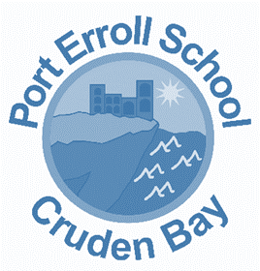

Port Erroll Primary School
Writing Policy
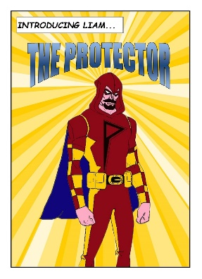
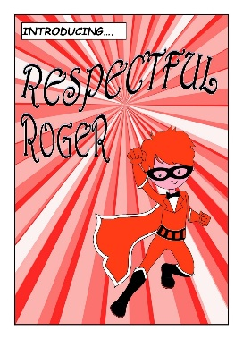
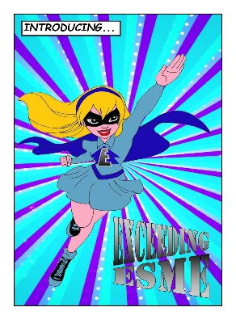
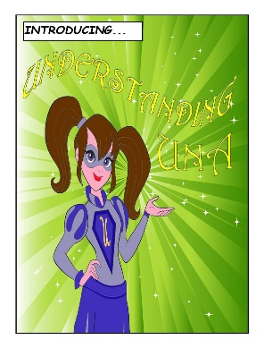
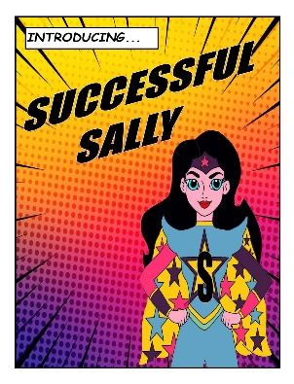
Date | January 2021
Review Date | January 2022

Overview
Writing is important in everyday life. It is integral to all aspects of life and, with this in mind, we endeavour to ensure that children develop a healthy and enthusiastic attitude towards writing.

Literacy skills empower individuals to unlock their potential as independent lifelong learners.

“Children and young people will demonstrate their progress in writing through the
degree of independence they show, the organisation and quality of their ideas,
their skills in spelling, punctuation and grammar, the match of their writing to
audience and the effectiveness of their use of language.”
Curriculum for Excellence

Rationale
We believe that the ability to write with confidence and accuracy is an essential life skill. We endeavour to enable all our children to communicate effectively using the printed word in a wide range of contexts. Writing is a complex process that requires many skills such as handwriting, spelling, sentence construction, grammar, punctuation and awareness of text structure and audience.

Aims
We aim to provide all pupils with a writing curriculum that is stimulating with adequate resources so that pupils can develop their writing skills to their full potential.

At Port Erroll Primary, we aim for each child to:
- Have a positive attitude towards writing.
- Write with confidence, clarity and imagination.
- Understand and apply their knowledge of phonics, spelling and handwriting.
- Write in a range of genres and text types.
- Plan, draft, revise and edit their own work and learn how to self and peer assess against success criteria or standards.
- Develop a technical vocabulary through which to understand and discuss their writing.
- Develop their imagination, creativity, expressive language and critical awareness through their writing.
- Write clearly, accurately and effectively for a range of audiences and purposes.

Organisation of Teaching and Learning

Writing in Port Erroll is taught and celebrated daily across a range of subjects. We aim wherever possible, to create cross-curricular writing opportunities.

Grammar, spelling and handwriting are important technical skills, which are developed through specifically taught lessons using active learning approaches. During writing lessons the children will be expected to demonstrate their ability to transfer these skills.

A taught writing lesson will be planned each week. During these lessons, planning will ensure that our ‘one page expectations’ are met.

Lessons typically follow this structure:
- Initial Planning/Pre writing stage
- Independent planning
- Model writing
- Independent writing and feedback

Three main areas of writing research underpin the teaching and learning of our writing.
- Talk for Writing : Pie Corbett.
- Big Writing : Ros Wilson.
- Explicitly Teaching Writing : Nelson.

Dictionaries -
Dictionaries and thesauruses provide writing assistance for writers of all levels of experience and ability. Explicit lessons to teach the use of these are a good idea to allow pupils to be able to use them with confidence during writing.

Target prompts / Success Criteria / Standards
Pupils should always be aware of where they are in their writing process and know what they need to develop in order to make progress. These are shared in a table format with either visual prompts or in script form. Differentiated targets show an understanding of individual learning needs.

Planning / Genre
At Port Erroll Primary we recognise the difference between text types and text forms.
Text Types  (These fall under the 3 bands,  Persuasive, Informative and Imaginative) | Discussion : To examine issues from more than one perspective.  Response : To respond to a visual, written or performed work.  Exposition : To persuade by arguing one side of an issue.  Report : To classify and/or describe.  Procedure : To instruct someone on how to do something.  Explanation : To explain why or how something occurs (present tense).  Recount : To retell a series of events (past tense).  Description : To describe the characteristics or features of a thing or phenomenon.  Narrative : To entertain, amuse or instruct.
Text Forms  A letter, for example, is a form of writing but it could be used to persuade someone, entertain or recount. | Posters, e-mails, blogs, pamphlets, letters, poems, stories, diaries, memoirs, recipes, rule books, directions, advertisements, newspaper articles, editorials, invitations, announcements, scripts, minutes of a meeting, comic strip, acrostics ……

Research shows that as children get older, their need to write using persuasive and informative text type increases. It is important that we ensure that each text type is taught in depth across the seven years of Primary schooling. To ensure breadth of experience, we have identified which text types will form a ‘focussed’ part of teaching for each year group. These are also selected to ensure each year group has experience in each of the three bands (persuasive, informative and imaginative).
Although the text types in the table below should be a ‘focus’ for that year group, other genres and types should/will inevitably be explored through other writing activities.
Year | Persuasive | Informative | Imaginative
P1 | Response – e.g. to a show, event or video clip | Recount – e.g. trip to the woods. | Description – e.g. favourite toy. What is your pirate like?
P2 | Response – e.g. to a circus act, picture of a circus performer | Report – e.g. classify and describe a dinosaur. | Description – e.g. Katie Morag link – what is her island like?
P3 | Exposition – e.g. persuade which weather is most important. | Recount – e.g. trip to the farm. The mummification process. | Narrative - e.g. weather mysteries / adventures, Egyptian tales.
P4 | Response – e.g. to Monet’s waterlily painting. | Explanation – e.g. explain the water cycle or life cycles. | Description – e.g. what a Roman is like.
P5 | Discussion -e.g. looking at both sides of rainforest destruction. | Procedure – e.g. How to make a burglar alarm. | Recount – e.g. battles
P6 | Exposition – e.g. rights of the child. | Description – e.g. Victorian people, jobs, places or objects. | Narrative – e.g. Space adventures and missions.
P7 | Discussion – e.g. perspectives of different political parties. | Explanation – e.g. Why WW2 began. | Description - e.g. Chinese/African traditions, characteristics.
*Composite classes should look at what has been covered by pupils previously and what is likely to still come and make selections under the 3 bands accordingly.

Marking, Assessment and Record Keeping
Feedback to pupils about their progress is achieved through discussion during the learning process, marking of work and discussion of progress following marking, during the writing lesson. This will take place either for the whole class or for a proportion of the class each week with the remainder of pupils self or peer assessing.

Effective marking :
-Aims to help pupils learn and comments are intended to be constructive, positive and forward-looking.
-Is often undertaken while a task is being carried out through over the shoulder marking. This takes the form of a discussion between the teacher and pupil and is appropriate to their age and ability.
-Is used sensitively and with discretion so that pupils assimilate a limited number of corrections at one time – this varies with age and ability.
-Informs discussion with pupils in relation to personal targets.

Assessment
Assessment is an integral part of the learning and teaching process. A balance between formative and summative assessment will be used to:
-Provide pupils with clear and regular feedback.
-Assist learners and teachers to plan next steps.
-Evaluate the effectiveness of teaching.

In order to effectively track progress of pupil attainment in writing, all pupils should undertake a baseline assessment. This assessment should be a piece of ‘unassisted’ writing. During the year, all pupils should complete a total of two pieces of ‘cold/unassisted’ writing, as outlined within the quality assurance calendar.

Monitoring and Tracking and Moderation
Moderation is key to ensuring that our professional judgement is accurate. This takes place termly as a staff team and twice yearly with local schools.

Support and Challenge
Pupils with additional support needs will be supported by a PSA or given further explanation and/or be supported individually by the class teacher. In some cases, pupils may be taught by an ASL teacher in small groups with planning being a collaborative process between class teacher and ASL teacher.
Provision to use assistive technology is also available through ‘touch typing’ and ‘read, write’ sessions.
A pupil whose difficulties are more complex may need to be supported with an individualised programme.

More able pupils will be taught within their own class and stretched through work and extra challenges which enrich learning. When working with the whole class, teachers will direct deeper learning questions towards the more able and adapt their tasks when relevant.

