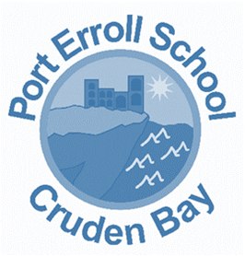

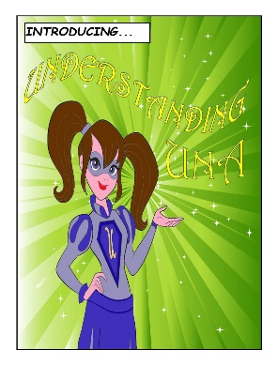
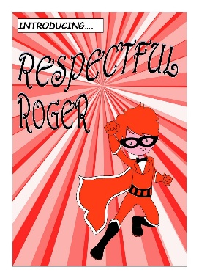
LITERACY POLICY
Updated: January 2023

Review: January 2025
Port Erroll Primary aims to raise standards in reading, writing, talking and listening. To equip our learners for life in the 21st century, it is vital that, as leaders of learning, teachers recognise the fundamental importance of literacy and its place in and across the curriculum. All teachers have a responsibility to promote and develop reading, writing, talking and listening skills.

In Port Erroll Primary School, we have a commitment to ensuring that our learners are equipped with the literacy skills which are required to become literate in the 21st century, including digital literacy.

Literacy is at the core of learning, and through the use of progressive programmes, learners in Port Erroll are supported in making links to literacy in all that they do.

Our staff work in a collegial manner to ensure that standards are shared across the school, in line with Aberdeenshire Progression Frameworks. We work together to moderate practice to ensure consistency and progression. We aim to naturally incorporate literacy into our programmes of work organically. Our learners value literacy as a key which allows access to the whole curriculum. Learners work within and through the significant aspects of learning of listening and talking, reading and writing. Staff use these significant aspects of learning within core literacy objectives and interdisciplinary learning projects.

Our aim is for learners to independently transfer their literacy skills across all areas of the curriculum. However, learners will engage in the following taught discrete weekly lessons: writing, spelling, grammar, comprehension and handwriting. Areas may be incorporated into active literacy lessons or it may have been decided to have a termly focus on an area as agreed with the Head Teacher, but spelling, comprehension and writing will be taught weekly with spelling being reinforced throughout the week.

The parents and carers at Port Erroll Primary School are encouraged to take an active role in their child’s learning. Through the delivery of parent and carer workshops, we aim to explore the importance of literacy across learning and provide guidance as how parents and carers can best support their child’s progress.

Our Literacy policy is built around the principles of our Curriculum Rationale. Through a collegial approach between pupils, staff and parents and carers, these principles are the foundation of our policy; our systems and programmes are the building blocks.

Assessment
Individual learners assess their own progress and evaluate their learning against the success criteria for a lesson, or series of lessons. Staff work in conjunction with learners through formative dialogue and written comments to highlight strengths and plan for next steps (see Writing Policy). Learners record evidence of their progress in their weekly Wakelets. Writing is formally assessed twice per year, reading and comprehension are assessed termly, listening and talking assessed twice a year and spelling weekly but more formally on a termly basis. The ASL teacher also carries out baseline assessments at the start of every year.

In Port Erroll Primary School, our Literacy Programme looks like:
Curriculum Area | What? How? Key Resources
Writing | See writing policy.
Reading | The Aberdeenshire Frameworks are used when planning learning experiences.  In nursery, reading is promoted through meaningful and child led play. Play is designed to encourage choice and independence and in tandem these experiences support children in developing their language and literacy skills. The children’s current interests and curiosities are embedded through the play opportunities that are available to them to ensure that children are stimulated and excited to learn.  In the Early Level we progress through the first 33 Initial Sounds of Jolly Phonics as well as the common words. We promote the use of environmental print, including ICT-based texts, across all stages of the school. Active literacy promotes reading 4 times per week, twice taught by the class teacher and twice read independently from P1-P3. Comprehension is fully embedded within these activities, as well as taught discretely at times.  From P4-P7 reading and comprehension is taught through the use of a class novel over two terms and children are taught in reading groups for the remaining two terms. Depending on the level of the reader, the ‘how often’ they should be taught reading will be decided by the class teacher and Head Teacher using their knowledge of the child as well as their professional judgement.  In Port Erroll Primary, our learners experience a variety of fiction and non-fiction genres. Learners’ comprehension is enhanced through Higher Order Thinking. Blooms based comprehension activities as well as the Nelson Comprehension scheme are used to help to enhance comprehension further. Reading Eggs and Eggspress is also a tool that is utilised throughout the school.  We created and agreed to a suggested structure for our reading lessons (see below) which links to our ‘one page expectations.’ By following a structure throughout the school, we can work to ensure a consistent approach to our reading lessons to support pace, breadth and challenge.  Suggested structure for P1 – P3.  Suggested structure for P4 – P7.
Listening and  Talking | The Aberdeenshire Frameworks are used when planning learning experiences.  Learners’ talk is assessed individually and as a group and this is moderated as can be difficult to access accurately and consistently.  Listening is embedded across the curriculum. We use Co-operative Learning approaches – focusing on Listening as a key social skill. We also develop listening and talking through reading and writing.

Planning and Tracking

Our programmes are tailored to the individual needs of learners. We work closely with our ASL teacher as well as other professionals to ensure that we tailor learning activities or supports in order for all children to achieve.

Within Port Erroll Primary School, staff plan their literacy experiences using the Aberdeenshire Frameworks. On a termly basis staff meet within their CfE levels to share their planning objectives and evaluate programmes of work with the Head Teacher. This allows for consistency across the level and school. Coverage of the Experiences and Outcomes is tracked at individual class level to ensure that learners engage in a breadth of learning experiences. Shared moderation activities allow staff to work in conjunction with one another and we use team teaching approaches wherever possible to utilise the skills of all staff. A shared planning approach allows for consistency within Port Erroll Primary School.

Through our observation model, the Senior Management Team work with staff to ensure that our learners have access to a consistent delivery of literacy experiences – tapping into the skills of our staff to develop literacy experiences across the school.

Our Literacy Policy continues to grow and develop. Staff and children continue to evaluate the policy. The Policy will be used to shape the Literacy experiences across the school; therefore making the Policy a ‘working’ document.

We seek feedback on our Literacy programmes when appropriate, to ensure that learners are progressively supported and challenged and provided with opportunities to experience success.

We will know the Literacy Policy is embedded fully when learners value literacy across the curriculum, practitioners feel confident in supporting and challenging all learners in literacy, and our literacy attainment increases across the school.

