C:\Users\Paul\AppData\Local\Microsoft\Windows\Temporary Internet Files\Content.IE5\3QB02RHG\MC900233966[1].wmf

Topic **– Transport and Travel – Land, Air and Sea**

Primary 2 are beginning a new topic all about transport.

The children will be discovering how transport is used in our local community, how transport is made, how it can impact our environment and how it has changed over the years.

The children will investigate how forces can make different things move through science and will design their own modes of transport through art and design.

We will also look at how maps are used for journeys and will learn how to use basic grid references and directions.

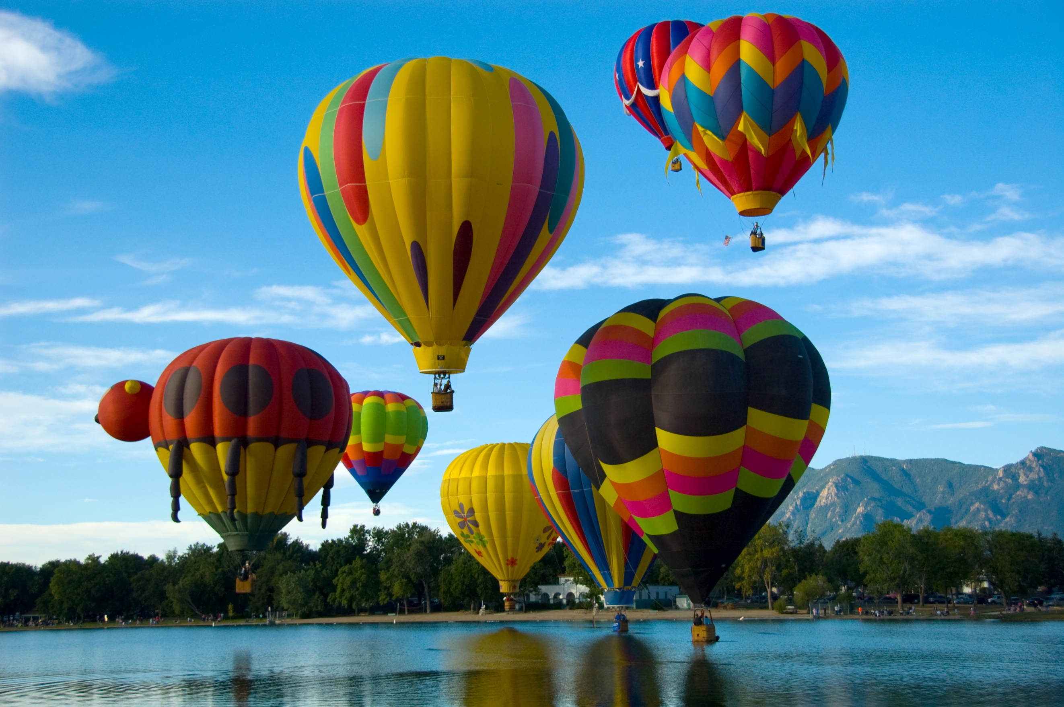

P2 Class News – Term 3

January 2024

*Welcome back to all pupils and families.*

*This newsletter will give you an idea of our planned activities in class this term.*

*We hope you find it useful.*

*Thank you for your continued support.*

*Mr Fyfe*



*Home/School Book*

*Please continue to sign and use the Home/School Book which lists reading activities, resources needed for school and can be used for home – school communication.*

**

Helpful Websites

BBC Bitesize Primary Scotland

<https://www.bbc.co.uk/bitesize/primary#scotland>

BBC Bitesize Games

<https://www.bbc.co.uk/bitesize/collections/primary-games/1>

**Homework**

Pupils will continue to get their spelling jotters home on a Monday for return on a Friday. They should **Look, Say, Cover, Write** and **Check** their words twice and complete an Active Spelling task (e.g. bubble writing, pyramid writing, etc). from the ‘Spell Well Activity’ leaflet within their homework folder.

**Reading Eggs**, **Maths Seeds** and **PurpleMash** logins are provided within the homework bag and are a fun way to reinforce the activities and learning covered within class.

Literacy:

This term our class will continue to write a range of different texts – imaginative stories, poems and non-fiction texts.

We will also be using our listening and talking skills to present work to others in class and to develop our discussion skills.

Numeracy:

This term your child will work on a range of areas of maths. These areas will include; number, place value, addition and subtraction with larger numbers, multiplication, division and fractions. We will continue to cover these throughout the school year.

Health and Wellbeing:

Your child will work on many activities that develop their physical and emotional wellbeing. These will be through class and peer discussion and reflection. We will also encourage the children to talk about social situations and their possible choices.

Physical Education:

This term our main activities in P.E. will be gymnastic skills and health and fitness. Activities will focus on body control and object control. We will be linking this to the physical and mental benefits of staying active.

Expressive Arts:

The children will present work linked to the topic of transport - using drama, music and art that conveys information to an audience and will show an increased level of control. They will produce a range of artwork and craft that shows their own ideas and detail.

Technology

The pupils will be working on lots of different technology activities this session, both online and offline. Pupils will also learn about using applications.

Science

This term we will be looking at transport and therefore discussing many different aspects of science that support this. We also plan to enter a competition that showcases our engineering skills.

**Reminders**

**Reading**

All pupils will be given reading books weekly throughout this term with notes made in their Home/School Book. Our groups will read twice a week on a **Monday** and **Thursday**.

Please could you sign in the space provided to indicate that your child has completed their reading.

**Clothing/Outdoor Learning**

Please ensure that your child follows the school uniform policy and that all property/clothing is clearly labelled to avoid confusion.

Outdoor Learning will be on a **Wednesday afternoon** so please ensure appropriate clothing in provided.

**PE Kits**

PE kits should be in school from Monday to Friday. Kits may then be taken home at weekends for washing if required. Our planned days for PE this term are **Monday** and **Friday.**